Peaches

Kasani Ingram1 and Owen Washam2

12024 Summer Intern, UNC - Greensboro

2Horticulture and Forestry Extension Agent, N.C. Cooperative Extension Montgomery County

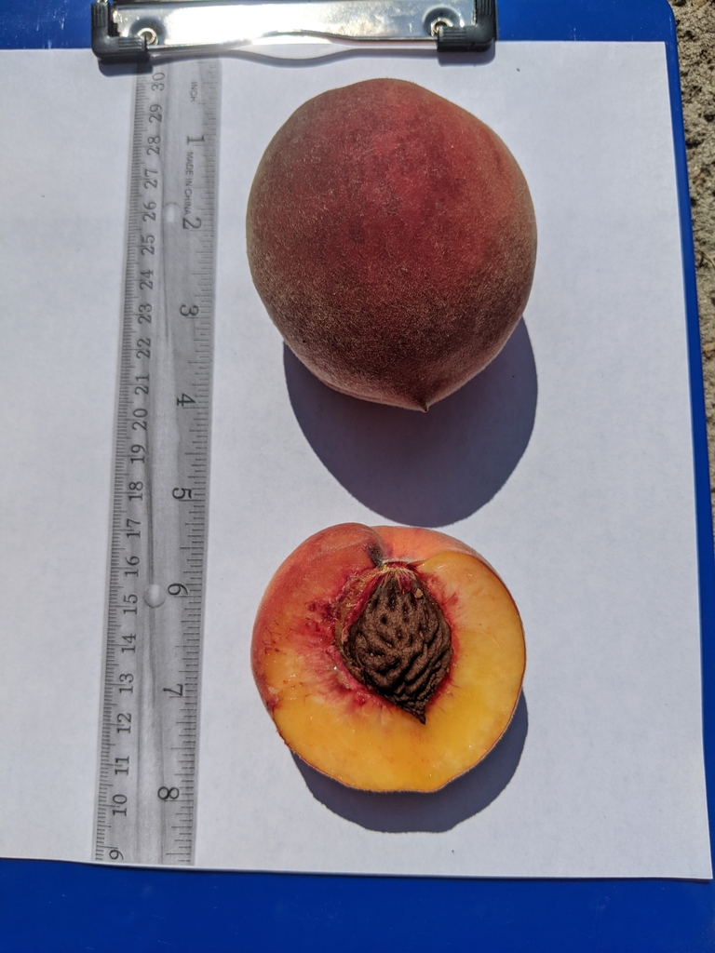Updated 8/2024

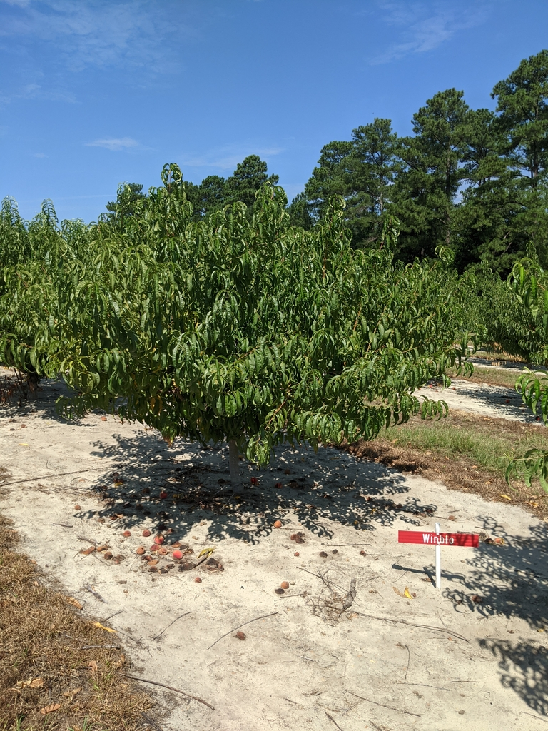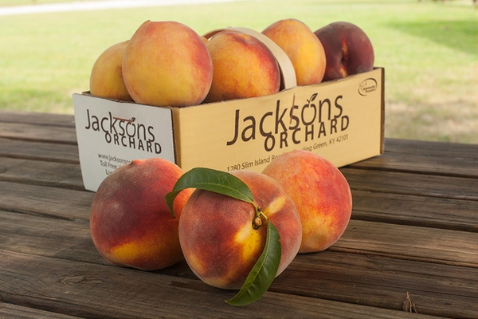

**Crop Local History:** In the past, peaches have been produced mostly in the Sandhills region of North Carolina. Locally this includes eastern Montgomery and Moore counties. Although the acreage has significantly declined over the past few decades, the Sandhills area has the largest concentration of peaches even today. Peaches are planted in various locations across the state as farmers aim to diversify their farming and marketing.

**Crop success comments for Montgomery County, specifically clay vs sandy soils:** North Carolina peaches are planted and grown in a variety of soil types. Peaches are grown on “sandy to sandy loam soils'', common in the Sandhills region. In the upper Piedmont and Mountains, peaches are typically planted in well-drained clays. Peach tree short life (PTSL) is common to peach-replant sites. PTSL is a disease complex can reduce the productive life of peach trees.

**Common NC Varieties:** There are100-200 different cultivars of peaches grown in the United States. Common North Carolina varieties include traditional yellow flesh peaches, white flesh peaches, flat peaches, round peaches, freestone, and clingstone peaches (Figure 1). Most white fleshed peaches are cultivated in China. Round peaches; your more circular peaches and the most common whereas flat peaches are typically rare. Clingstone peaches are those where the flesh tends to “cling” to the pit of the peach, whereas the pit of freestone peaches tends to separate easily from the flesh. Freestones are considered easier to consume for this reason. Freestone peaches are also known to be larger than clingstones.

**Planting:** Once choosing a suitable peach to grow, it is also equally important that you choose the best growing site. Well drained soil areas that receive a lot of sunlight are considered one of the best environments to plant peaches.

**Figure 1. Common Peach varieties in North Carolina.**

|  |  |  |  |
| --- | --- | --- | --- |
| ***Peach Variety*** | ***Approximate Ripening Date*** | ***Flesh Color*** | ***Stone Freeness*** |
| Summerprince | June 20 | Yellow | semi-free |
| Harvester | June 25 | Yellow | free |
| Carolina Belle | June 30 | White | free |
| Winblo | July 4 | Yellow | free |
| Fireprince | July 5 | Yellow | free |
| Big Mac | July 10 | Yellow | free |
| Contender | July 10 | Yellow | free |
| Loring | July 15 | Yellow | free |
| July Prince | July 15 | Yellow | free |
| Ruston Red | July 20 | Yellow | free |
| Blushing Star | July 20 | White | free |
| Cresthaven | July 25 | Yellow | free |
| Georgia Belle | July 25 | White | free |
| Sunprince | July 25 | Yellow | free |
| Early August Prince | July 25 | Yellow | free |
| China Pearl | July 30 | White | free |
| Tyler | July 30 | Yellow | free |
| August Prince | August 5 | Yellow | free |
| Carolina Gold | August 5 | Yellow | free |
| White Star | August 5 | White | free |
| Flameprince | August 10 | Yellow | free |
| Sweet Sue | August 10 | Yellow | free |
| Big Red | August 20 | Yellow | free |
| Parade | August 25 | Yellow | free |
| Fairtime | September 1 | Yellow | free |
| September Snow | September 1 | White | free |
| Autumnprince | September 10 | Yellow | free |
| Sweet September | September 15 | Yellow | free |

**Field and Crop Management:** While peaches offer profitable opportunities for various production systems, peach orchards require a high amount of preparation, maintenance, labor, and attention from producers. Home growers may work with a reduced scale, selecting 1 or a few trees to try in their garden.

Weeds are removed from peach orchards through Chemical Control and Mechanical Control. Some pre-emergent herbicides labeled for peaches are Simazine, Diuron, Terbacil, Norflurazon, and Flumioxazin.

Post-emergence herbicides labeled for peaches include 2,4-D, Paraquat, Glyphosate, Glufosinate, Sethoxydim, Clethodim, and Fluazifop. Prior to any pesticide application, consult the NC Ag Chemical Manual and follow all pesticide label instructions.

**Common Seasonal issues:** Numerous plant pests and pathogens affect peaches. In the home garden, control starts with cultural practices. Be sure to prune out dead or diseased wood, remove old fruits and fallen leaves, and keep the trunk area clean and weed free. Some common diseases include brown rot, peach scab, bacterial spot, and leaf curl. Common pests include plum curculio, oriental peach moths, peach borers, catfacing insects, and scale.

For chemical control of these issues, contact N.C. Cooperative Extension or consult the NC Agricultural Chemicals Manual for the latest recommendations.

**Harvesting Practices:** North Carolina peaches are not typically sold at grocery stores. They are sold at fresh markets, roadside stands, farmers markets, and festivals. In this case peach growers do not rely on refrigeration to store ready for eating peaches. Instead, they focus on their sales and marketing to get fresh, tree-ripened peaches in the hands of their customers.

**Where to purchase planting material:** Many home stores offer planting material for those interested in planting peaches. These include Montgomery Farm and Garden, Tractor Supply, and Lowes. For specific varieties, a mail order is often needed. It is important to get a tree grafted onto a Guardian rootstock, which can limit PTSL effects. Two reputable sources, both in McMinnville TN, are Cumberland Valley Nursery and Vaughn Nursery.

**Cumberland Valley Nursery**

PO Box 471

McMinnville, TN 371111-0471

[fruitrus@benlomand.net](mailto:fruitrus@benlomand.net)

931-668-4153

**Vaughn Nursery**

8678 Smithville Highway

McMinnville, TN 37110

[vaughnnursery@benlomand.net](mailto:vaughnnursery@benlomand.net)

(931)934-2715

<https://vaughnnursery.com/>

**Where to purchase peaches:** In Montgomery County, local peaches are typically available for purchase from farm stands and at farmer markets from May to September. The majority of peach production is centered in the sandhills region in the southeast part of the county around Candor. Below are options for purchasing fresh, local peaches.

**Parson’s Farm LLC**

909 NC-211, Candor, NC 27229

910-975-4237

<https://www.facebook.com/parsonsfarmllc>

**Kalawi Farm & Ben’s Ice Cream**

1515 NC-211, Eagle Springs, NC 27242

910-673-5996

<https://www.facebook.com/kalawifarm/>

**Ken Chappell Peaches**

672 NC-211, Eagle Springs, NC 27242

910-673-1878

<https://chappellpeaches.com/>

**Hillcrest Peaches**

672 Spicewood Rd., Eagle Springs, NC 27242

910-220-2004

[Donnaharris2004@gmail.com](mailto:Donnaharris2004@gmail.com)

<https://www.facebook.com/profile.php?id=61559798530415>

**Freeman’s Peaches**

2460 N.C. Highway 731 E. Candor, 27229

<http://www.buyncpeaches.com/showdetails.php?ID=144>

910-974-4815

**Carter Farms**

673 Eagle Springs Rd., Eagle Springs, NC 27242

<https://www.ncfarmfresh.com/FarmMarketDisplay.asp?FarmID=1268>

(office) 910-673-7730

(home) 910-673-2666

**OTHER FUN FACTS**

* NC harvested 1,200 acres of peaches (2016) contributing nearly $7 million in annual sales.
* North Carolina is the 7th top producer of peaches nationally, producing an average of 3.6 million pounds for the fresh market each year (2016 USDA).
* The average NC peach season is about 4 months, spanning from June – September and peaking in July.
* North Carolina common peach varieties include Bisco, Candor, Carolina Belle, Derby, and Norman.
* The annual [NC Peach Festival](https://www.facebook.com/NCPeachFestival/) is hosted in Candor, NC on the third Saturday in July.

**References**

Burns, P. (2024). Postharvest handling. Raleigh; North Carolina State University. Retrieved on August 1, 2024 from

<https://peaches.ces.ncsu.edu/peaches-postharvest-handling/>.

Clemson University. (2001). Clemson University - Variety Evaluations. Clemson; Clemson University. Retrieved on

August 1, 2024 from <https://www.clemsonpeach.org/>

Haseler, J. (2020). All about Peaches. Ithaca; Cornell University. Retrieved on August 1, 2024 from

<https://monroe.cce.cornell.edu/agriculture/seasonal-produce-highlights/all-about-peaches#:~:text=With%20clingstone%20peaches%2C%20the%20flesh%20%E2%80%9Cclings%E2%80%9D%20to%20the,the%20flesh%2C%20making%20it%20ideal%20for%20fresh%20consumption>.

Layne, D., (2010). Different kinds of Peaches. Clemson; Clemson University. Retrieved on August 1, 2024 from

<https://hgic.clemson.edu/different-kinds-of-peaches/>

Parker, M. (2024). Production and Management. Raleigh; North Carolina State University. Retrieved on August 1,

2024 from <https://peaches.ces.ncsu.edu/peachesproduction-and-management/>

Parker, M., Ritchie, D., Sorensen, K., Meyer, J., & Mitchem, W. (2005). Crop Profile for Peaches in North Carolina.

Raleigh; North Carolina State University. Retrieved on August 1, 2024 from <https://ipmdata.ipmcenters.org/documents/cropprofiles/NCpeach2005.pdf>